Business Level Principles for the Population of Data with Regard to Investigation Centric and Microbiology Request and Reports
Amendment History:
Version | Date | Amendment History
0.1 |  | First draft for comment
0.2 | 22/12/05 | Following consultation re format of document
0.3 | 09/01/06 | Following comments
0.4 | 17/01/06 | Title change an addition of principles and examples for investigation centric reports
0.5 | 31/01/06 | Further changes
0.6 | 01/02/06 | Further changes following comments
0.7 | 06/02/06 | Further changes
0.8 | 14/02/06 | Changes following review
1.0 | 22/02/06 | Approved
Forecast Changes:
Anticipated Change | When
Changes following review in MiM 5.0 | After Feb 2006
Reviewers:
This document must be reviewed by the following:
Name | Signature | Title / Responsibility | Date | Version
Denis Hutchinson |  | Senior Business Analyst | 14/02/06 | 0.8
Patrick Mitchell-Jones |  | Core Technical Team Manager | 14/02/06 | 0.8
Simon Withey |  | DSRRD Design Lead | 14/02/06 | 0.8
The document has also been reviewed by the Pathology Review Group
Approvals:
This document must be approved by the following:
Name | Signature | Title / Responsibility | Date | Version
Sally Stanley |  | DSRRD Project Manager | 14/02/06 | 0.8

Document Status:
This is a controlled document.
Whilst this document may be printed, the electronic version maintained in FileCM is the controlled copy. Any printed copies of the document are not controlled.
Related Documents:
These documents will provide additional information.
Ref no | Doc Reference Number | Title | Version
1 | NPFIT-SHR-QMS-PRP-0015 | Glossary of Terms Consolidated.doc | 11
2 | NPFIT-SHR-MODL-PMLLAB-0011.11 | W5 Communication definition for Pathology v1.0.doc | 1.0
Glossary of Terms:
Term | Acronym | Definition
Investigation centric report |  | An investigation centric report is one in which the entire report is produced for one requested order line item purpose only and, to meet that requested order item, multiple specimens have been analysed
Specimen centric report |  | One or more specimens upon which one or more investigations, or order line items have been made. The specimens and/or investigations may or may not be related.

Contents
1 About this Document 5
1.1 Purpose 5
1.2 Audience 5
1.3 Content 5
2 Principles used for placing of data in the structure 5
2.1 Investigation centric requests and reports 5
2.2 Microbiology culture reports 6
3 Example Use of Report Information Structure 8
3.1 Pathology Report Summary Class Diagram (as displayed in the W5) 9
3.2 Examples of Microbiology Reports 10
3.2.1 Example 1: Throat swab for C&S 10
3.2.2 Example 2: Wound swab from suture line re-opened for C&S 12
3.2.3 Example 3: Urine (MSU) for Micro, Culture & Sensitivities 18
3.2.4 Example 4: Left Ear swab for C&S 25
3.2.5 Example 5: Faeces for culture - Campylobacter isolated 35
3.2.6 Example 6: Faeces for culture - Campylobacter not isolated 38
3.2.7 Example 7: Wound swab with mixed coliforms and Bacteroides sp 41
3.2.8 Example 8: HVS with N. gonorrhoea isolated and Trichomonas vaginalis seen 46
3.2.9 Example 9: Staphylococcal Phage typing 52
3.3 Examples of Investigation Centric Reports 56
3.3.1 Example 1: MRSA Screen – multiple specimens 56
3.3.2 Example 2: Glucose Tolerance Test – multiple specimens 66
3.3.3 Example 3: Creatinine clearance test – multiple specimens 78

About this Document

Purpose
There are a number of important relationships between the data within a laboratory report that must be preserved and portrayed consistently in order to satisfy the business requirements of the service, irrespective of the message format used for communicating that report. The complexity of the resulting structure is such that additional guidance on intended use is required and provided herein. The concern is that there should be clarity of understanding to ensure that a standard population of the information structure is established
This document has been produced in order to illustrate the relationships identified in the document, W5 Communication definition for Pathology v1.0.doc¹ with respect to Microbiology reports and Investigation centric reports and to encourage standardisation and a common understanding.
The examples provided in the appendix serve to demonstrate the principles rather than provide any data for testing purposes.

Audience
- Solution providers
- Test assurance staff
- Pathology review group

Content
- Principles for Investigation centric requests and reports
- Principles for the placing of data in microbiology reports
- Example Use of Report Information Structure

Principles used for placing of data in the structure
As with most communications, there are different ways in which data may be represented. Whilst the detailed documentation provided with the messages will identify correct use of the particular message components, there are some important principles that need to be followed, as it is clearly not possible to document all possible scenarios.

Investigation centric requests and reports
An investigation centric request or report is one in which the entire report is produced for one requested order line item purpose only and, to meet that requested order item, multiple specimens have been analysed. Examples of such reports include Dynamic Function Tests (Glucose Tolerance Test), Creatinine Clearance and Microbiology Screening Reports. Future examples include ‘sub-arachnoid haemorrhage’ analysis which involves investigations on CSF and blood with an interpretation, based on these findings, entered on one report.
The principles used are as follows:-
- It is not mandatory, at this stage, for sending systems to support the investigation centric report information structure described.
- Receiving systems will be required to support the structure from adoption of the resulting message standard.
- If an Investigation Centric Test is reported, the communication shall only include related batteries or tests
- A Laboratory service provider's comment on a report for an Investigation Centric test (described in the Investigation centric report details section of the W5) may be used to give a text comment to the whole report.
- It is not mandatory to include a comment within the investigation centric report. In which case the investigation centric investigation acts merely as a ‘grouper’ to link the associated specimens and specimen centric investigations
- If there is a calculated numeric result (such as creatinine clearance), the investigation containing the result shall be attached to one of the specimens associated with the report level order item.
- If there is a calculated result, the investigation may be associated with a battery with the same name as the investigation centric investigation. For example, the report containing the investigation centric investigation ‘creatinine clearance test’ may also contain the battery or standalone investigation of ‘creatinine clearance test’ at specimen level (e.g. a urine specimen)

Microbiology culture reports
The principles used are as follows:-
- All tests and batteries of investigations shall have a relationship to the substance on which they were performed/observed. This may be a sample or an Isolate.
For example, investigations performed on the specimen rather than the isolate (e.g. urine microscopy) shall maintain a relationship to the specimen upon which they were carried out, as a text value or numeric value either individually or within a battery
- Where appropriate, isolates shall have a relationship to the sample from which they were obtained.
- All investigations and batteries of investigations shall have an identifiable display order such that a system rendering the information may reproduce the intended sequence.
For example, In order to maintain appropriate representation of antibiotic sensitivity tests performed and reported on an isolate, the order in which they shall be displayed shall be communicated and honoured in any rendering of those tests. In the same way in which any investigations are ordered within a battery and batteries are ordered within a report.
- 'Any named positive isolate shall be carried in the Isolate section if it is considered (by the fulfiller) to be significant although they may also be recorded elsewhere. For example ‘A heavy growth of mixed coliforms and Bacteroides sp’ can be carried in the text result of the culture performed on a specimen, but if the Bacteroides sp is judged to be a significant isolate then it must also be carried in the Isolates section
This includes viruses, parasites and fungi even when identified by methods other than culture. However, this principle should only apply to the actual entity, or when evidence of its physical presence is seen e.g. culture, microscopy or direct antibody tests. Indirect evidence of existence such as the presence of Hepatits B surface antigen (HbSAg positive), although indicative of Hepatitis B infection should not be recorded as an ‘Isolate’.
- Any observations made about that isolate regarding its presence shall be carried as an investigation (e.g. determination of organism growth) associated with that isolate. Examples include degrees of presence (few, some, many, heavy, moderate etc) temperature at which isolated time taken to be detected growth conditions (aerobic, anaerobic) etc.
- Details of culture results associated with the specimen without a named, identified organism should be carried at specimen level as text or coded. Examples: Normal Flora only, No growth after 3 days incubation. NB. This includes the absence of any named organism(s) e.g. Campylobacter not isolated
- Isolate names shall be limited to Genus or Species. Phage types and Serotypes do not constitute different species and shall be carried as findings of that isolate.
- Antibiotic sensitivity tests shall be carried as investigations, optionally within a battery carried out upon the isolate. As such, there shall be a relationship maintained between the isolate and any sensitivity results obtained for it.
For example, the battery shall be SnCT coded as ‘sensitivity tests’ and each individual investigations within the battery will be the SnCT code, for antimicrobial susceptibility test, post co-ordinated with the method and antibiotic tested against.
.

Example Use of Report Information Structure
The following examples are provided to indicate which data items are populated within a report communication for the given results. The object diagram can be mapped to the relevant portion of the summary class diagram below. As the purpose of this paper is to describe the principles and provide examples of which data items are populated for microbiology (with particular regard to isolate information data), and investigation centric reports the following points should be noted:
- The examples are derived from the W5 data content and structure and therefore do not represent the HL7 format of the communication
- Items such as ‘placer request ID’ etc are not represented
- Only the first few investigations within a battery of investigations are represented
- Objects detail is only provided for specimen information, and below, in the information structure
- SnCT codes used in the illustrative data structures are examples of existing SnCT codes and do not represent items from the pathology catalogue or are intended to indicate that these codes should be used in implementation

Pathology Report Summary Class Diagram (as displayed in the W5)
Due to page constraints, a full class diagram is not practical. This diagram is a representation of the class structure of the data items as defined in the W5.
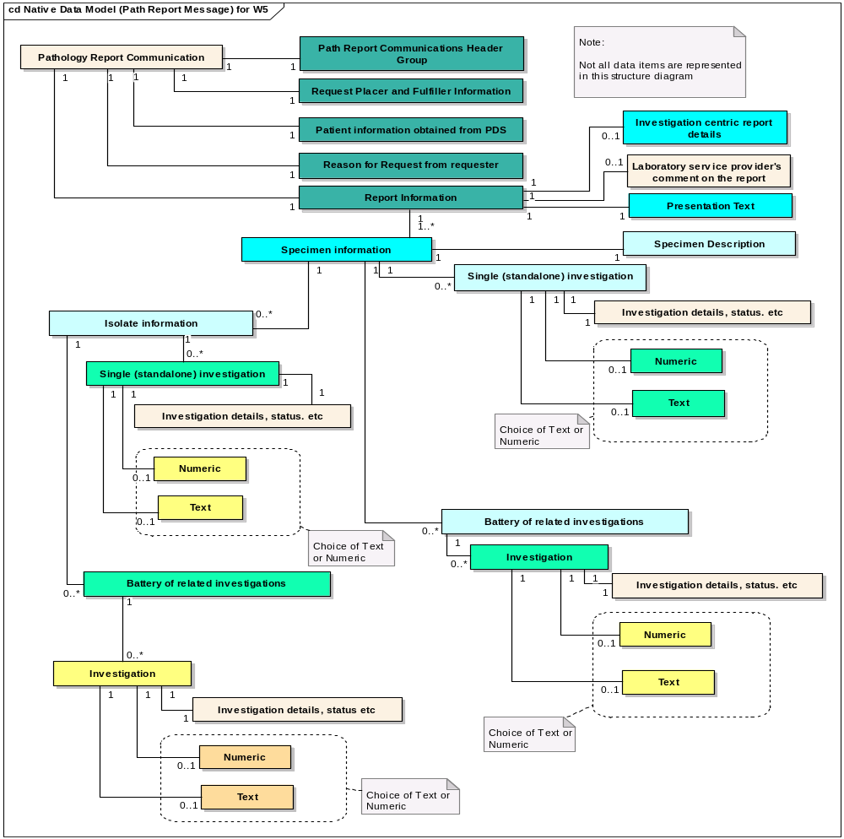

Examples of Microbiology Reports

Example 1: Throat swab for C&S
Request: Throat swab for C&S.
: Result: Normal Flora only

Human readable representation of reported data items
MESSAGE : ICR 114 / MRN 2 GENERATED : 08:23 28/07/2003
REQUESTER : DR JONES S
RECIPIENT : DR JONES S
ANY TOWN SURGERY, ANY STREET, ANY VILLAGE, ANY TOWN, ANY COUNTY
PROVIDER : Medical Microbiology, ANY NHS Trust
REPORT : MIC0210620307280800M,03.0025368A001 ISSUED : 08:00 28/07/2003
PATIENT : TESTPATIENT, EDI 25/12/1929 Female NHS: 999 999 9999
Address Line 1, Address Line 2, Address Line 3, Address Line 4, Addre+

Tonsillitis
COLLECTED : 25/07/2003
M,03.0025368.DA RECEIVED : 14:55 25/07/2003
Spec.Type: Throat swab

Culture Normal flora

Object Diagram and attribute values
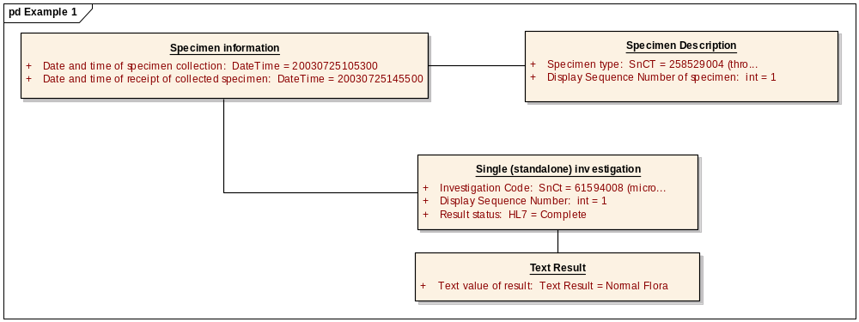

Single (standalone) investigation
Object:

Single (standalone) investigation Attributes
Attribute | Type | Notes
Investigation Code | SnCt | Initial Value: 61594008 (microbial culture)
Display Sequence Number | int | Initial Value: 1
Result status | HL7 | Initial Value: Complete

Specimen Description
Object:

Specimen Description Attributes
Attribute | Type | Notes
Specimen type | SnCT | Initial Value: 258529004 (throat swab)
Display Sequence Number of specimen | int | Initial Value: 1

Specimen information
Object:

Specimen information Attributes
Attribute | Type | Notes
Date and time of specimen collection | DateTime | Initial Value: 20030725105300
Date and time of receipt of collected specimen | DateTime | Initial Value: 20030725145500

Text Result
Object:

Text Result Attributes
Attribute | Type | Notes
Text value of result | Text Result | Initial Value: Normal Flora

Example 2: Wound swab from suture line re-opened for C&S
Request: Wound swab from suture line re-opened for C&S
Report: Significant organism isolated with antibiotic sensitivities

Human readable representation of reported data items
MESSAGE : ICR 121 / MRN 1 GENERATED : 08:56 11/08/2003
REQUESTER : DR JONES S
RECIPIENT : DR JONES S
ANY TOWN SURGERY, ANY STREET, ANY VILLAGE, ANY TOWN, ANY COUNTY
PROVIDER : Medical Microbiology, ANY NHS Trust
REPORT : MIC0211590308110800M,03.0026922A001 ISSUED : 08:00 11/08/2003
PATIENT : TESTPATIENT, EDI 25/12/1929 Female NHS: 999 999 9999
Address Line 1, Address Line 2, Address Line 3, Address Line 4, Addre+

suture line inflamed
COLLECTED : 07/08/2003
M,03.0026922.AA RECEIVED : 14:30 07/08/2003
Spec.Type: Wound Swab Morphology: Operative site suture line re-opened

C&S - Culture and sensitivities

(1) Staph aureus : Heavy Growth
(1)
Penicillin R
Flucloxacillin S
Cephalexin S
Augmentin S
Erythromycin S
Tetracycline S
Trimethoprim S

Object Diagram and attribute values
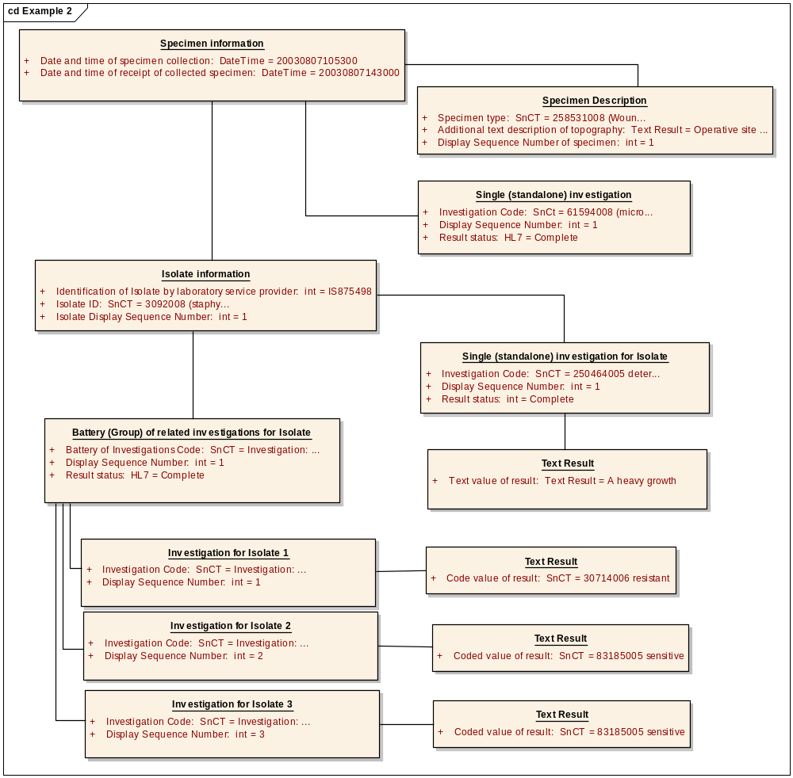

Specimen information
Object:

Specimen information Attributes
Attribute | Type | Notes
Date and time of specimen collection | DateTime | Initial Value: 20030807105300
Date and time of receipt of collected specimen | DateTime | Initial Value: 20030807143000

Specimen Description
Object:

Specimen Description Attributes
Attribute | Type | Notes
Specimen type | SnCT | Initial Value: 258531008 (Wound Swab)
Additional text description of topography | Text Result | Initial Value: Operative site suture line re-opened
Display Sequence Number of specimen | int | Initial Value: 1

Single (standalone) investigation
Object:

Single (standalone) investigation Attributes
Attribute | Type | Notes
Investigation Code | SnCt | Initial Value: 61594008 (microbial culture)
Display Sequence Number | int | Initial Value: 1
Result status | HL7 | Initial Value: Complete

Isolate information
Object:

Isolate information Attributes
Attribute | Type | Notes
Identification of Isolate by laboratory service provider | int | Initial Value: IS875498
Isolate ID | SnCT | Initial Value: 3092008 (staphylococcus aureus)
Isolate Display Sequence Number | int | Initial Value: 1

Single (standalone) investigation for Isolate
Object:

Single (standalone) investigation for Isolate Attributes
Attribute | Type | Notes
Investigation Code | SnCT | Initial Value: 250464005 determination of organism growth
Display Sequence Number | int | Initial Value: 1
Result status | int | Initial Value: Complete

Text Result
Object:

Text Result Attributes
Attribute | Type | Notes
Text value of result | Text Result | Initial Value: A heavy growth

Battery (Group) of related investigations for Isolate
Object:

Battery (Group) of related investigations for Isolate Attributes
Attribute | Type | Notes
Battery of Investigations Code | SnCT | Initial Value: Investigation: 359867004: antibiotic sensitivity, disk method (procedure)
Display Sequence Number | int | Initial Value: 1
Result status | HL7 | Initial Value: Complete

Investigation for Isolate 1
Object:

Investigation for Isolate 1 Attributes
Attribute | Type | Notes
Investigation Code | SnCT | Initial Value: Investigation: 14788002: antimicrobial susceptibility test (procedure) + SnCT code for disc method + 373270004: penicillin -class of antibiotic- (substance)
Display Sequence Number | int | Initial Value: 1

Text Result
Object:

Text Result Attributes
Attribute | Type | Notes
Code value of result | SnCT | Initial Value: 30714006 resistant

Investigation for Isolate 2
Object:

Investigation for Isolate 2 Attributes
Attribute | Type | Notes
Investigation Code | SnCT | Initial Value: Investigation: 14788002: antimicrobial susceptibility test (procedure) + SnCT code for disc method + 387544009 (floxacillin)
Display Sequence Number | int | Initial Value: 2

Text Result
Object:

Text Result Attributes
Attribute | Type | Notes
Coded value of result | SnCT | Initial Value: 83185005 sensitive

Investigation for Isolate 3
Object:

Investigation for Isolate 3 Attributes
Attribute | Type | Notes
Investigation Code | SnCT | Initial Value: Investigation: 14788002: antimicrobial susceptibility test (procedure) + SnCT code for disc method + 387304003 (cephalexin)
Display Sequence Number | int | Initial Value: 3

Text Result
Object:

Text Result Attributes
Attribute | Type | Notes
Coded value of result | SnCT | Initial Value: 83185005 sensitive

Example 3: Urine (MSU) for Micro, Culture & Sensitivities
Request: Urine (MSU) for Micro, Culture & Senstivities
Report: Significant organism isolated with antibiotic sensitivities

Human readable representation of reported data items
MESSAGE : ICR 33 / MRN 1 GENERATED : 10:15 15/11/2002
REQUESTER : DR JONES S
RECIPIENT : DR JONES S
ANY TOWN SURGERY, ANY STREET, ANY VILLAGE, ANY TOWN, ANY COUNTY
PROVIDER : Medical Microbiology, ANY NHS Trust
REPORT : MIC0201810211151000U,02.0047444A001 ISSUED : 10:00 15/11/2002
PATIENT : TESTPATIENT, EDI 25/12/1929 Female NHS: 999 999 9999
Address Line 1, Address Line 2, Address Line 3, Address Line 4, Addre+
SPEC.TYPE: MSU COLLECTED : 13/11/2002
U,02.0047444.BA RECEIVED : 15:02 13/11/2002
Spec.Type: MSU

Microscopic Urinalysis
Leucocytes : 200 phpf
Erythrocytes : 0 phpf
Organisms : Some
Epithelial Cells : Some

(1)Coliform sp. : Signicant growth
(1)
Amoxycillin S
Trimethoprim S
Nalidixic Acid S
Cephalexin S
Nitrofurantoin S
Augmentin S

Object Diagram and attribute values
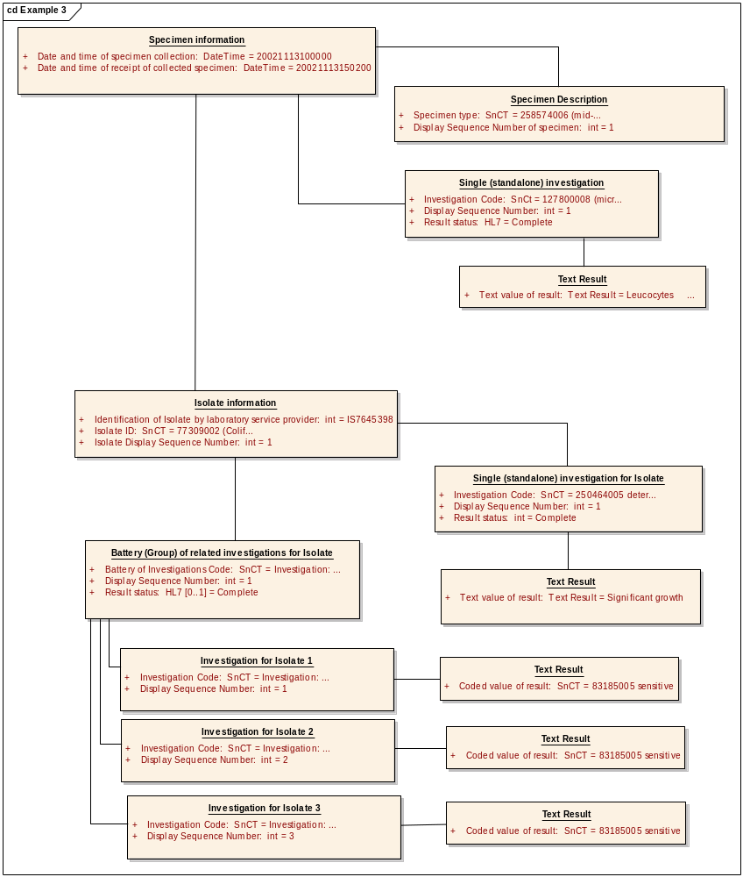

Specimen information
Object:

Specimen information Attributes
Attribute | Type | Notes
Date and time of specimen collection | DateTime | Initial Value: 20021113100000
Date and time of receipt of collected specimen | DateTime | Initial Value: 20021113150200

Specimen Description
Object:

Specimen Description Attributes
Attribute | Type | Notes
Specimen type | SnCT | Initial Value: 258574006 (mid-stream urine sample)
Display Sequence Number of specimen | int | Initial Value: 1

Single (standalone) investigation
Object:

Single (standalone) investigation Attributes
Attribute | Type | Notes
Investigation Code | SnCt | Initial Value: 127800008 (microscopic urinalysis)
Display Sequence Number | int | Initial Value: 1
Result status | HL7 | Initial Value: Complete

Text Result
Object:

Text Result Attributes
Attribute | Type | Notes
Text value of result | Text Result | Initial Value: Leucocytes : 200 phpf Erythrocytes : 0 phpf Organisms : Some Epithelial Cells : Some

Isolate information
Object:

Isolate information Attributes
Attribute | Type | Notes
Identification of Isolate by laboratory service provider | int | Initial Value: IS7645398
Isolate ID | SnCT | Initial Value: 77309002 (Coliform bacteria)
Isolate Display Sequence Number | int | Initial Value: 1

Single (standalone) investigation for Isolate
Object:

Single (standalone) investigation for Isolate Attributes
Attribute | Type | Notes
Investigation Code | SnCT | Initial Value: 250464005 determination of organism growth
Display Sequence Number | int | Initial Value: 1
Result status | int | Initial Value: Complete

Text Result
Object:

Text Result Attributes
Attribute | Type | Notes
Text value of result | Text Result | Initial Value: Significant growth

Battery (Group) of related investigations for Isolate
Object:

Battery (Group) of related investigations for Isolate Attributes
Attribute | Type | Notes
Battery of Investigations Code | SnCT | Initial Value: Investigation: 359867004: antibiotic sensitivity, disk method (procedure)
Display Sequence Number | int | Initial Value: 1
Result status | Range:0 to 1:  HL7 | Initial Value: Complete

Investigation for Isolate 1
Object:

Investigation for Isolate 1 Attributes
Attribute | Type | Notes
Investigation Code | SnCT | Initial Value: Investigation: 14788002: antimicrobial susceptibility test (procedure) + SnCT code for disc method + 372687004: amoxycillin -class of antibiotic- (substance)
Display Sequence Number | int | Initial Value: 1

Text Result
Object:

Text Result Attributes
Attribute | Type | Notes
Coded value of result | SnCT | Initial Value: 83185005 sensitive

Investigation for Isolate 2
Object:

Investigation for Isolate 2 Attributes
Attribute | Type | Notes
Investigation Code | SnCT | Initial Value: Investigation: 14788002: antimicrobial susceptibility test (procedure) + SnCT code for disc method + 387179001(Trimethoprim)
Display Sequence Number | int | Initial Value: 2

Text Result
Object:

Text Result Attributes
Attribute | Type | Notes
Coded value of result | SnCT | Initial Value: 83185005 sensitive

Investigation for Isolate 3
Object:

Investigation for Isolate 3 Attributes
Attribute | Type | Notes
Investigation Code | SnCT | Initial Value: Investigation: 14788002: antimicrobial susceptibility test (procedure) + SnCT code for disc method + 387261006 (Nalidixic Acid)
Display Sequence Number | int | Initial Value: 3

Text Result
Object:

Text Result Attributes
Attribute | Type | Notes
Coded value of result | SnCT | Initial Value: 83185005 sensitive

Example 4: Left Ear swab for C&S
Request: Left Ear swab for C&S
Report: Staph and Esch. coli isolated with sensitivities

Human readable representation of reported data items
MESSAGE : ICR 104 / MRN 5 GENERATED : 12:35 27/06/2003
REQUESTER : DR JONES S
RECIPIENT : DR JONES S
ANY TOWN SURGERY, ANY STREET, ANY VILLAGE, ANY TOWN, ANY COUNTY
PROVIDER : Medical Microbiology, ANY NHS Trust
REPORT : MIC0209180306271200M,03.0021317A001 ISSUED : 12:00 27/06/2003
PATIENT : TESTPATIENT, EDI 25/12/1929 Male NHS: 999 999 9999
Address Line 1, Address Line 2, Address Line 3, Address Line 4, Addre+

Discharge
SPEC.TYPE: EAR SWAB QUAL.: LEFT COLLECTED : 25/06/2003
M,03.0021317.MA RECEIVED : 12:12 25/06/2003
Spec.Type: Ear swab Qual.: left

1 Staph aureus : Scanty growth
2 coliform sp : Heavy growth
1 2 1 2
Flucloxacillin S Chloramphenicol S
Penicillin R Amoxicillin R S
Trimethoprim S S Cefotetan S
Cefuroxime S Teicoplanin S
Vancomycin S
Gentamicin S S
Ciprofloxacin S S

Object Diagram and attribute values
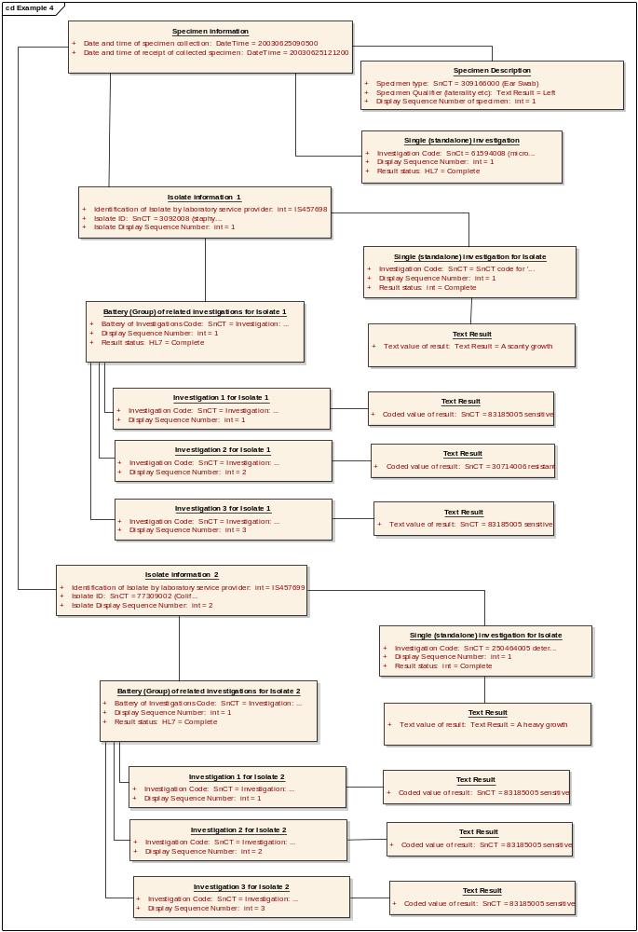

Specimen information
Object:

Specimen information Attributes
Attribute | Type | Notes
Date and time of specimen collection | DateTime | Initial Value: 20030625090500
Date and time of receipt of collected specimen | DateTime | Initial Value: 20030625121200

Specimen Description
Object:

Specimen Description Attributes
Attribute | Type | Notes
Specimen type | SnCT | Initial Value: 309166000 (Ear Swab)
Specimen Qualifier (laterality etc) | Text Result | Initial Value: Left
Display Sequence Number of specimen | int | Initial Value: 1

Single (standalone) investigation
Object:

Single (standalone) investigation Attributes
Attribute | Type | Notes
Investigation Code | SnCt | Initial Value: 61594008 (microbial culture)
Display Sequence Number | int | Initial Value: 1
Result status | HL7 | Initial Value: Complete

Isolate information 1
Object:

Isolate information 1 Attributes
Attribute | Type | Notes
Identification of Isolate by laboratory service provider | int | Initial Value: IS457698
Isolate ID | SnCT | Initial Value: 3092008 (staphylococcus aureus)
Isolate Display Sequence Number | int | Initial Value: 1

Single (standalone) investigation for Isolate
Object:

Single (standalone) investigation for Isolate Attributes
Attribute | Type | Notes
Investigation Code | SnCT | Initial Value: SnCT code for 'growth attribute'
Display Sequence Number | int | Initial Value: 1
Result status | int | Initial Value: Complete

Text Result
Object:

Text Result Attributes
Attribute | Type | Notes
Text value of result | Text Result | Initial Value: A scanty growth

Battery (Group) of related investigations for Isolate 1
Object:

Battery (Group) of related investigations for Isolate 1 Attributes
Attribute | Type | Notes
Battery of Investigations Code | SnCT | Initial Value: Investigation: 359867004: antibiotic sensitivity, disk method (procedure)
Display Sequence Number | int | Initial Value: 1
Result status | HL7 | Initial Value: Complete

Investigation 1 for Isolate 1
Object:

Investigation 1 for Isolate 1 Attributes
Attribute | Type | Notes
Investigation Code | SnCT | Initial Value: Investigation: 14788002: antimicrobial susceptibility test (procedure) + SnCT code for disc method + 387544009 (floxacillin)
Display Sequence Number | int | Initial Value: 1

Text Result
Object:

Text Result Attributes
Attribute | Type | Notes
Coded value of result | SnCT | Initial Value: 83185005 sensitive

Investigation 2 for Isolate 1
Object:

Investigation 2 for Isolate 1 Attributes
Attribute | Type | Notes
Investigation Code | SnCT | Initial Value: Investigation: 14788002: antimicrobial susceptibility test (procedure) + SnCT code for disc method + 373270004: penicillin -class of antibiotic- (substance)
Display Sequence Number | int | Initial Value: 2

Text Result
Object:

Text Result Attributes
Attribute | Type | Notes
Coded value of result | SnCT | Initial Value: 30714006 resistant

Investigation 3 for Isolate 1
Object:

Investigation 3 for Isolate 1 Attributes
Attribute | Type | Notes
Investigation Code | SnCT | Initial Value: Investigation: 14788002: antimicrobial susceptibility test (procedure) + SnCT code for disc method + 387179001(Trimethoprim)
Display Sequence Number | int | Initial Value: 3

Text Result
Object:

Text Result Attributes
Attribute | Type | Notes
Text value of result | SnCT | Initial Value: 83185005 sensitive

Isolate information 2
Object:

Isolate information 2 Attributes
Attribute | Type | Notes
Identification of Isolate by laboratory service provider | int | Initial Value: IS457699
Isolate ID | SnCT | Initial Value: 77309002 (Coliform bacteria)
Isolate Display Sequence Number | int | Initial Value: 2

Single (standalone) investigation for Isolate
Object:

Single (standalone) investigation for Isolate Attributes
Attribute | Type | Notes
Investigation Code | SnCT | Initial Value: 250464005 determination of organism growth
Display Sequence Number | int | Initial Value: 1
Result status | int | Initial Value: Complete

Text Result
Object:

Text Result Attributes
Attribute | Type | Notes
Text value of result | Text Result | Initial Value: A heavy growth

Battery (Group) of related investigations for Isolate 2
Object:

Battery (Group) of related investigations for Isolate 2 Attributes
Attribute | Type | Notes
Battery of Investigations Code | SnCT | Initial Value: Investigation: 359867004: antibiotic sensitivity, disk method (procedure)
Display Sequence Number | int | Initial Value: 1
Result status | HL7 | Initial Value: Complete

Investigation 1 for Isolate 2
Object:

Investigation 1 for Isolate 2 Attributes
Attribute | Type | Notes
Investigation Code | SnCT | Initial Value: Investigation: 14788002: antimicrobial susceptibility test (procedure) + SnCT code for disc method + 387179001(Trimethoprim)
Display Sequence Number | int | Initial Value: 1

Text Result
Object:

Text Result Attributes
Attribute | Type | Notes
Coded value of result | SnCT | Initial Value: 83185005 sensitive

Investigation 2 for Isolate 2
Object:

Investigation 2 for Isolate 2 Attributes
Attribute | Type | Notes
Investigation Code | SnCT | Initial Value: Investigation: 14788002: antimicrobial susceptibility test (procedure) + SnCT code for disc method + 372833007 (cefuroxime)
Display Sequence Number | int | Initial Value: 2

Text Result
Object:

Text Result Attributes
Attribute | Type | Notes
Coded value of result | SnCT | Initial Value: 83185005 sensitive

Investigation 3 for Isolate 2
Object:

Investigation 3 for Isolate 2 Attributes
Attribute | Type | Notes
Investigation Code | SnCT | Initial Value: Investigation: 14788002: antimicrobial susceptibility test (procedure) + SnCT code for disc method + 387321007 (gentamicin)
Display Sequence Number | int | Initial Value: 3

Text Result
Object:

Text Result Attributes
Attribute | Type | Notes
Coded value of result | SnCT | Initial Value: 83185005 sensitive

Example 5: Faeces for culture - Campylobacter isolated
Request: Faeces for culture
Report: Campylobacter isolated

Human readable representation of reported data items
MESSAGE : ICR 86 / MRN 4 GENERATED : 14:23 21/03/2003
REQUESTER : DR JONES S
RECIPIENT : DR JONES S
ANY TOWN SURGERY, ANY STREET, ANY VILLAGE, ANY TOWN, ANY COUNTY
PROVIDER : Medical Microbiology, ANY NHS Trust
REPORT : MIC0205960303211400S,03.0002942A001 ISSUED : 14:00 21/03/2003
PATIENT : TESTPATIENT, EDI 25/12/1929 Male NHS: 999 999 9999
Address Line 1, Address Line 2, Address Line 3, Address Line 4, Addre+

Loose stools
SPEC.TYPE: FAECES COLLECTED : 19/03/2003
S,03.0002942.HA RECEIVED : 12:11 19/03/2003
Spec.Type: Faeces

(1) Campylobacter sp.: isolated

Object Diagram and attribute values
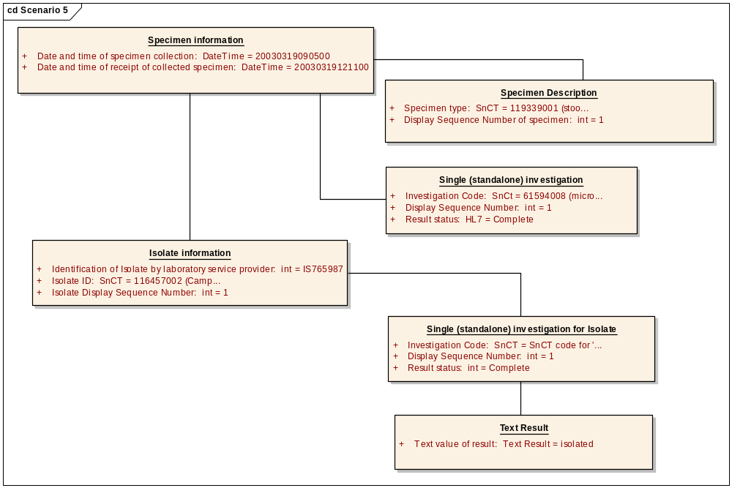

Specimen information
Object:

Specimen information Attributes
Attribute | Type | Notes
Date and time of specimen collection | DateTime | Initial Value: 20030319090500
Date and time of receipt of collected specimen | DateTime | Initial Value: 20030319121100

Specimen Description
Object:

Specimen Description Attributes
Attribute | Type | Notes
Specimen type | SnCT | Initial Value: 119339001 (stool specimen)
Display Sequence Number of specimen | int | Initial Value: 1

Single (standalone) investigation
Object:

Single (standalone) investigation Attributes
Attribute | Type | Notes
Investigation Code | SnCt | Initial Value: 61594008 (microbial culture)
Display Sequence Number | int | Initial Value: 1
Result status | HL7 | Initial Value: Complete

Isolate information
Object:

Isolate information Attributes
Attribute | Type | Notes
Identification of Isolate by laboratory service provider | int | Initial Value: IS765987
Isolate ID | SnCT | Initial Value: 116457002 (Campylobacter species)
Isolate Display Sequence Number | int | Initial Value: 1

Single (standalone) investigation for Isolate
Object:

Single (standalone) investigation for Isolate Attributes
Attribute | Type | Notes
Investigation Code | SnCT | Initial Value: SnCT code for 'growth attribute'
Display Sequence Number | int | Initial Value: 1
Result status | int | Initial Value: Complete

Text Result
Object:

Text Result Attributes
Attribute | Type | Notes
Text value of result | Text Result | Initial Value: isolated

Example 6: Faeces for culture - Campylobacter not isolated
Request: Faeces for culture. (previous Campylobacter, check if clear)
Report: Campylobacter not isolated

Human readable representation of reported data items
MESSAGE : ICR 86 / MRN 4 GENERATED : 14:23 21/03/2003
REQUESTER : DR JONES S
RECIPIENT : DR JONES S
ANY TOWN SURGERY, ANY STREET, ANY VILLAGE, ANY TOWN, ANY COUNTY
PROVIDER : Medical Microbiology, ANY NHS Trust
REPORT : MIC0205960303211400S,03.0002942A001 ISSUED : 14:00 21/03/2003
PATIENT : TESTPATIENT, EDI 25/12/1929 Male NHS: 999 999 9999
Address Line 1, Address Line 2, Address Line 3, Address Line 4, Addre+

Loose stools
SPEC.TYPE: FAECES COLLECTED : 19/03/2003
S,03.0002942.HA RECEIVED : 12:11 19/03/2003
Spec.Type: Faeces

Culture:

Campylobacter sp. not isolated

Object Diagram and attribute values
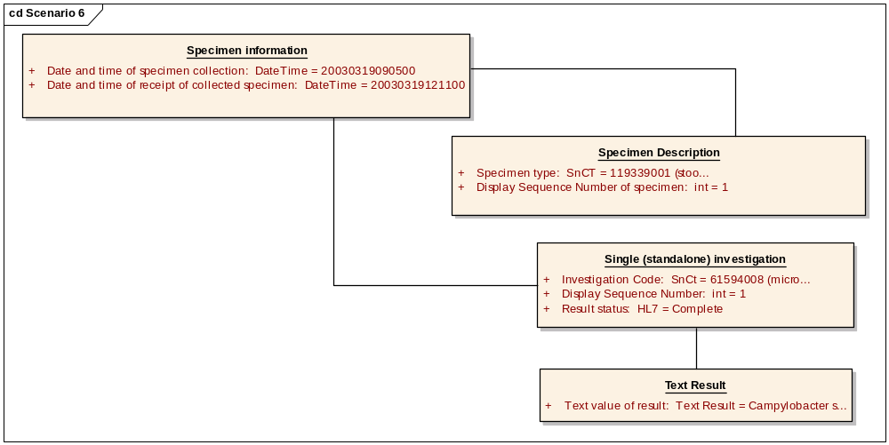

Specimen information
Object:

Specimen information Attributes
Attribute | Type | Notes
Date and time of specimen collection | DateTime | Initial Value: 20030319090500
Date and time of receipt of collected specimen | DateTime | Initial Value: 20030319121100

Specimen Description
Object:

Specimen Description Attributes
Attribute | Type | Notes
Specimen type | SnCT | Initial Value: 119339001 (stool specimen)
Display Sequence Number of specimen | int | Initial Value: 1

Single (standalone) investigation
Object:

Single (standalone) investigation Attributes
Attribute | Type | Notes
Investigation Code | SnCt | Initial Value: 61594008 (microbial culture)
Display Sequence Number | int | Initial Value: 1
Result status | HL7 | Initial Value: Complete

Text Result
Object:

Text Result Attributes
Attribute | Type | Notes
Text value of result | Text Result | Initial Value: Campylobacter sp not isolated

Example 7: Wound swab with mixed coliforms and Bacteroides sp
Request: W/S from Abdomen
Report: mixed coliforms and significant growth of Bacteroides sp

Human readable representation of reported data items
MESSAGE : ICR 192 / MRN 1 GENERATED : 12:50 05/01/2004
REQUESTER : DR JONES S
RECIPIENT : DR JONES S
ANY TOWN SURGERY, ANY STREET, ANY VILLAGE, ANY TOWN, ANY COUNTY
PROVIDER : Medical Microbiology, ANY NHS Trust
REPORT : MIC0222270401051230M,04.0000042A001 ISSUED : 12:30 05/01/2004
PATIENT : TESTPATIENT, EDI 25/12/1929 Male NHS: 999 999 9999
Address Line 1, Address Line 2, Address Line 3, Address Line 4, Addre+
SPEC.TYPE: WOUND SWAB COLLECTED : 02/01/2004
M,04.0000042.SA RECEIVED : 13:24 02/01/2004
Spec.Type: Wound swab

Culture and Sensitivities

A heavy growth of mixed coliforms and Bacteroides sp
(1) Bacteroides
(1)
Metronidazole S

Object Diagram and attribute values
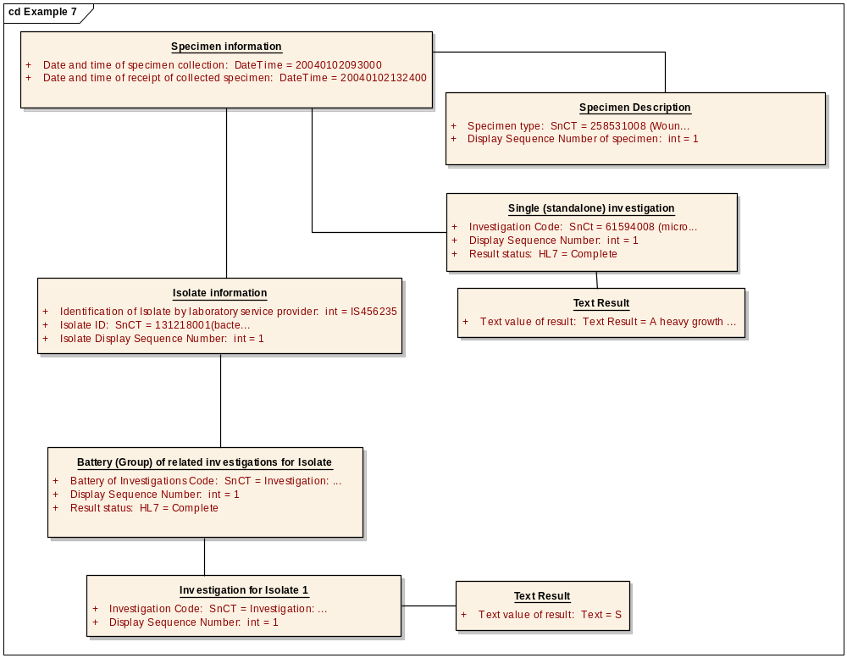

Specimen information
Object:

Specimen information Attributes
Attribute | Type | Notes
Date and time of specimen collection | DateTime | Initial Value: 20040102093000
Date and time of receipt of collected specimen | DateTime | Initial Value: 20040102132400

Specimen Description
Object:

Specimen Description Attributes
Attribute | Type | Notes
Specimen type | SnCT | Initial Value: 258531008 (Wound Swab)
Display Sequence Number of specimen | int | Initial Value: 1

Single (standalone) investigation
Object:

Single (standalone) investigation Attributes
Attribute | Type | Notes
Investigation Code | SnCt | Initial Value: 61594008 (microbial culture)
Display Sequence Number | int | Initial Value: 1
Result status | HL7 | Initial Value: Complete

Isolate information
Object:

Isolate information Attributes
Attribute | Type | Notes
Identification of Isolate by laboratory service provider | int | Initial Value: IS456235
Isolate ID | SnCT | Initial Value: 131218001(bacteroides species)
Isolate Display Sequence Number | int | Initial Value: 1

Text Result
Object:

Text Result Attributes
Attribute | Type | Notes
Text value of result | Text Result | Initial Value: A heavy growth of mixed coliforms and Bacteroides sp

Battery (Group) of related investigations for Isolate
Object:

Battery (Group) of related investigations for Isolate Attributes
Attribute | Type | Notes
Battery of Investigations Code | SnCT | Initial Value: Investigation: 359867004: antibiotic sensitivity, disk method (procedure)
Display Sequence Number | int | Initial Value: 1
Result status | HL7 | Initial Value: Complete

Investigation for Isolate 1
Object:

Investigation for Isolate 1 Attributes
Attribute | Type | Notes
Investigation Code | SnCT | Initial Value: Investigation: 14788002: antimicrobial susceptibility test (procedure) + SnCT code for disc method + 372602008 (metronidazole)
Display Sequence Number | int | Initial Value: 1

Text Result
Object:

Text Result Attributes
Attribute | Type | Notes
Text value of result | Text | Initial Value: S

Example 8: HVS with N. gonorrhoea isolated and Trichomonas vaginalis seen
Request: HVS
Report: N.gonorrhoeae isolated, TV present

Human readable representation of reported data items
MESSAGE : ICR 41 / MRN 3 GENERATED : 10:37 20/12/2002
REQUESTER : DR JONES S
RECIPIENT : DR JONES S
ANY TOWN SURGERY, ANY STREET, ANY VILLAGE, ANY TOWN, ANY COUNTY
PROVIDER : Medical Microbiology, ANY NHS Trust
REPORT : MIC0203010212201000M,02.0043103A001 ISSUED : 10:00 20/12/2002
PATIENT : TESTPATIENT, EDI 25/12/1929 Female NHS: 999 999 9999
Address Line 1, Address Line 2, Address Line 3, Address Line 4, Addre+

Pain
SPEC.TYPE: HVS COLLECTED : 18/12/2002
M,02.0043103.QA RECEIVED : 15:16 18/12/2002
Spec.Type: HVS

(1) N.gonorrhoeae: Moderate growth
(2) Trichomonas vaginalis: present

(1)
Penicillin S

Object Diagram and attribute values
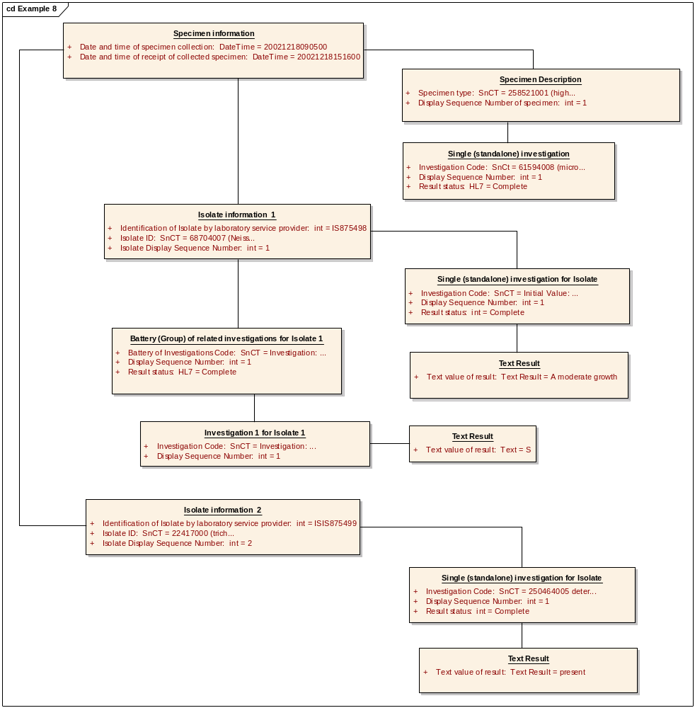

Specimen information
Object:

Specimen information Attributes
Attribute | Type | Notes
Date and time of specimen collection | DateTime | Initial Value: 20021218090500
Date and time of receipt of collected specimen | DateTime | Initial Value: 20021218151600

Specimen Description
Object:

Specimen Description Attributes
Attribute | Type | Notes
Specimen type | SnCT | Initial Value: 258521001 (high vaginal swab)
Display Sequence Number of specimen | int | Initial Value: 1

Single (standalone) investigation
Object:

Single (standalone) investigation Attributes
Attribute | Type | Notes
Investigation Code | SnCt | Initial Value: 61594008 (microbial culture)
Display Sequence Number | int | Initial Value: 1
Result status | HL7 | Initial Value: Complete

Isolate information 1
Object:

Isolate information 1 Attributes
Attribute | Type | Notes
Identification of Isolate by laboratory service provider | int | Initial Value: IS875498
Isolate ID | SnCT | Initial Value: 68704007 (Neisseria gonorrhoeae)
Isolate Display Sequence Number | int | Initial Value: 1

Single (standalone) investigation for Isolate
Object:

Single (standalone) investigation for Isolate Attributes
Attribute | Type | Notes
Investigation Code | SnCT | Initial Value: 250464005 determination of organism growth
Display Sequence Number | int | Initial Value: 1
Result status | int | Initial Value: Complete

Text Result
Object:

Text Result Attributes
Attribute | Type | Notes
Text value of result | Text Result | Initial Value: A moderate growth

Battery (Group) of related investigations for Isolate 1
Object:

Battery (Group) of related investigations for Isolate 1 Attributes
Attribute | Type | Notes
Battery of Investigations Code | SnCT | Initial Value: Investigation: 359867004: antibiotic sensitivity, disk method (procedure)
Display Sequence Number | int | Initial Value: 1
Result status | HL7 | Initial Value: Complete

Investigation 1 for Isolate 1
Object:

Investigation 1 for Isolate 1 Attributes
Attribute | Type | Notes
Investigation Code | SnCT | Initial Value: Investigation: 14788002: antimicrobial susceptibility test (procedure) + SnCT code for disc method + 373270004: penicillin -class of antibiotic- (substance)
Display Sequence Number | int | Initial Value: 1

Text Result
Object:

Text Result Attributes
Attribute | Type | Notes
Text value of result | Text | Initial Value: S

Isolate information 2
Object:

Isolate information 2 Attributes
Attribute | Type | Notes
Identification of Isolate by laboratory service provider | int | Initial Value: ISIS875499
Isolate ID | SnCT | Initial Value: 22417000 (trichomonas vaginalis)
Isolate Display Sequence Number | int | Initial Value: 2

Single (standalone) investigation for Isolate
Object:

Single (standalone) investigation for Isolate Attributes
Attribute | Type | Notes
Investigation Code | SnCT | Initial Value: 250464005 determination of organism growth
Display Sequence Number | int | Initial Value: 1
Result status | int | Initial Value: Complete

Text Result
Object:

Text Result Attributes
Attribute | Type | Notes
Text value of result | Text Result | Initial Value: present

Example 9: Staphylococcal Phage typing
Request: Staphylococcal phage typing
Report: Phage type report

Human readable representation of reported data items
MESSAGE : ICR 41 / MRN 3 GENERATED : 10:37 20/12/2002
REQUESTER : DR JONES S
RECIPIENT : DR JONES S
ANY TOWN SURGERY, ANY STREET, ANY VILLAGE, ANY TOWN, ANY COUNTY
PROVIDER : Medical Microbiology, ANY NHS Trust
REPORT : MIC0203010212201000M,02.0043103A001 ISSUED : 10:00 20/12/2002
PATIENT : TESTPATIENT, EDI 25/12/1929 Female NHS: 999 999 9999
Address Line 1, Address Line 2, Address Line 3, Address Line 4, Addre+

COLLECTED : 18/12/2002
RECEIVED : 15:16 18/12/2002

1. Staphylococcus aureus
Phage Type: Distinct strain
S.aureus toxin gene detection:
sea –
seb –
sec –
sed –
see –
seg +
she –
sei +
sej –
tst +
eta –
etb –
etd –
luk –
PV –
Result comment:
This isolate has an unrecognised phage pattern, therefore likely to be sporadic in occurrence.

Object Diagram and attribute values

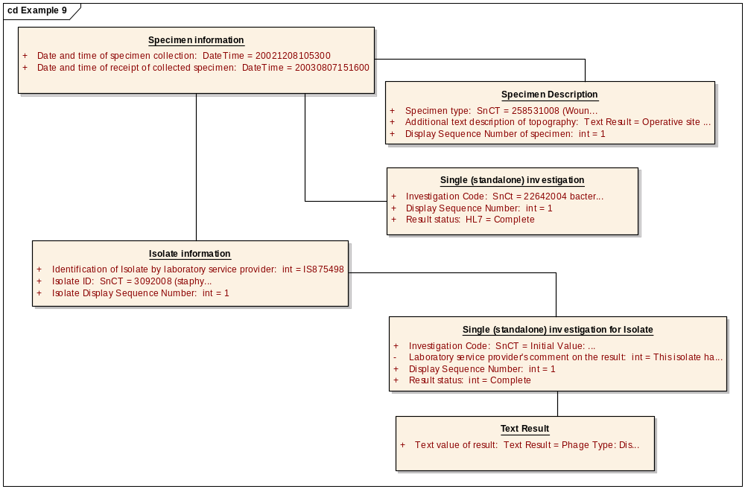

Specimen information
Object:

Specimen information Attributes
Attribute | Type | Notes
Date and time of specimen collection | DateTime | Initial Value: 20021208105300
Date and time of receipt of collected specimen | DateTime | Initial Value: 20030807151600

Specimen Description
Object:

Specimen Description Attributes
Attribute | Type | Notes
Specimen type | SnCT | Initial Value: 258531008 (Wound Swab)
Additional text description of topography | Text Result | Initial Value: Operative site suture line re-opened
Display Sequence Number of specimen | int | Initial Value: 1

Single (standalone) investigation
Object:

Single (standalone) investigation Attributes
Attribute | Type | Notes
Investigation Code | SnCt | Initial Value: 22642004 bacterial bactriophage typing
Display Sequence Number | int | Initial Value: 1
Result status | HL7 | Initial Value: Complete

Isolate information
Object:

Isolate information Attributes
Attribute | Type | Notes
Identification of Isolate by laboratory service provider | int | Initial Value: IS875498
Isolate ID | SnCT | Initial Value: 3092008 (staphylococcus aureus)
Isolate Display Sequence Number | int | Initial Value: 1

Single (standalone) investigation for Isolate
Object:

Single (standalone) investigation for Isolate Attributes
Attribute | Type | Notes
Investigation Code | SnCT | Initial Value: SnCT code for 'toxic gene detection'
Laboratory service provider's comment on the result | private :  int | Initial Value: This isolate has an unrecognised phage pattern, therefore likely to be sporadic in occurrence
Display Sequence Number | int | Initial Value: 1
Result status | int | Initial Value: Complete

Text Result
Object:

Text Result Attributes
Attribute | Type | Notes
Text value of result | Text Result | Initial Value: Phage Type: Distinct strainS.aureus toxin gene detection:sea -seb -sec -sed -see -seg +she -sei +sej -tst +eta -etb -etd -luk -PV -

Examples of Investigation Centric Reports

Example 1: MRSA Screen – multiple specimens
Request: MRSA Screen
Report: One site has produced Staph aureus, resistant to methicillin

Human readable representation of reported data items

MESSAGE : ICR 41 / MRN 3 GENERATED : 10:37 20/12/2002
REQUESTER : DR JONES S
RECIPIENT : DR JONES S
ANY TOWN SURGERY, ANY STREET, ANY VILLAGE, ANY TOWN, ANY COUNTY
PROVIDER : Medical Microbiology, ANY NHS Trust
REPORT : MIC0203010212201000M,02.0043103A001 ISSUED : 10:00 20/12/2002
PATIENT : TESTPATIENT, EDI 25/12/1929 Female NHS: 999 999 9999
Address Line 1, Address Line 2, Address Line 3, Address Line 4, Addre+

Pain
COLLECTED : 18/12/2002
RECEIVED : 15:16 18/12/2002

MRSA Screen
MRSA Detected

Perineal Swab M C & S
MRSA not detected
Throat Swab M C & S
MRSA not detected
Wound Swab M,C & S
MRSA detected
Staph Aureus +++
R
Methicillin R
Gentamicin S
Vancomicin S
S

Object Diagram and attribute values
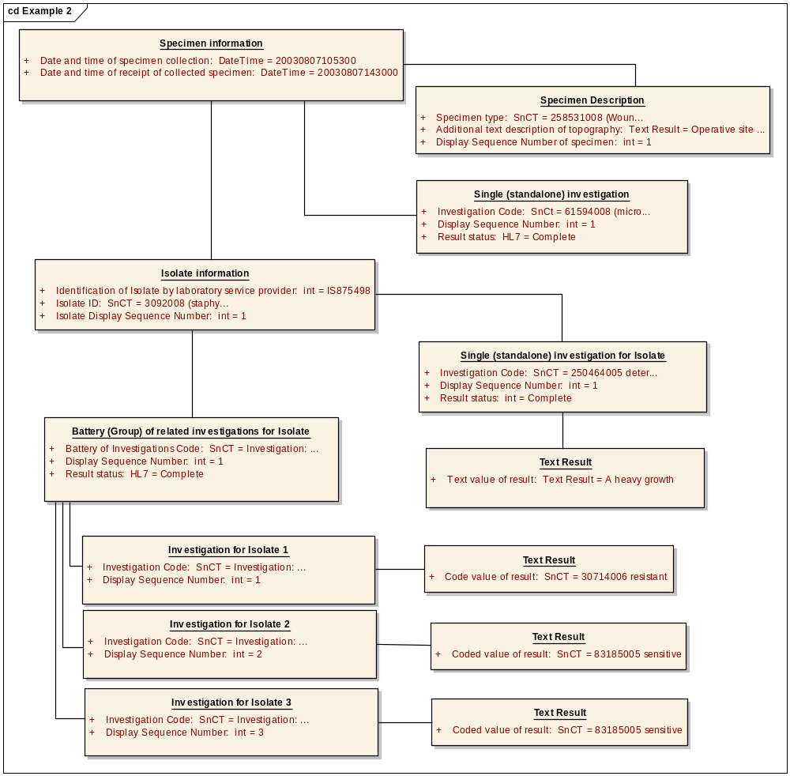

Report Information
Object:

Investigation centric report details
Object: This is for one investigation on a number of samples eg GTT. MRSA screen, creatinine clearance. Other investigations must not be included at this level or non-related investigations included at lower levels

Investigation centric report details Attributes
Attribute | Type | Notes
Investigation Code | SnCT | Initial Value: 401289003 (methicillin resistant staphylococcus aureus screening test)
Laboratory service provider's comment on the report | Range:0 to 1:  Text | Initial Value: MRSA Detected

Specimen information 1
Object:

Specimen information 1 Attributes
Attribute | Type | Notes
Date and time of specimen collection | DateTime | Initial Value: 20021218095300
Date and time of receipt of collected specimen | DateTime | Initial Value: 20021218151600

Specimen Description 1
Object:

Specimen Description 1 Attributes
Attribute | Type | Notes
Specimen type | SnCT | Initial Value: 258525005 (perineal Swab)
Display Sequence Number of specimen | int | Initial Value: 1

Single (standalone) investigation
Object:

Single (standalone) investigation Attributes
Attribute | Type | Notes
Investigation Code | SnCt | Initial Value: 61594008 (microbial culture)
Display Sequence Number | int | Initial Value: 1
Result status | HL7 | Initial Value: Complete

Text Result
Object:

Text Result Attributes
Attribute | Type | Notes
Text value of result | Text Result | Initial Value: MRSA not detected

Specimen information 2
Object:

Specimen information 2 Attributes
Attribute | Type | Notes
Date and time of specimen collection | DateTime | Initial Value: 20021218095300
Date and time of receipt of collected specimen | DateTime | Initial Value: 20021218151600

Specimen Description 2
Object:

Specimen Description 2 Attributes
Attribute | Type | Notes
Specimen type | SnCT | Initial Value: 258529004 (Throat Swab)
Display Sequence Number of specimen | int | Initial Value: 2

Single (standalone) investigation
Object:

Single (standalone) investigation Attributes
Attribute | Type | Notes
Investigation Code | SnCt | Initial Value: 61594008 (microbial culture)
Display Sequence Number | int | Initial Value: 1
Result status | HL7 | Initial Value: Complete

Text Result
Object:

Text Result Attributes
Attribute | Type | Notes
Text value of result | Text Result | Initial Value: MRSA not detected

Specimen information 3
Object:

Specimen information 3 Attributes
Attribute | Type | Notes
Date and time of specimen collection | DateTime | Initial Value: 20021218095300
Date and time of receipt of collected specimen | DateTime | Initial Value: 20021218151600

Specimen Description 3
Object:

Specimen Description 3 Attributes
Attribute | Type | Notes
Specimen type | SnCT | Initial Value: 258531008 (Wound Swab)
Display Sequence Number of specimen | int | Initial Value: 3

Single (standalone) investigation
Object:

Single (standalone) investigation Attributes
Attribute | Type | Notes
Investigation Code | SnCt | Initial Value: 61594008 (microbial culture)
Display Sequence Number | int | Initial Value: 1
Result status | HL7 | Initial Value: Complete

Text Result
Object:

Text Result Attributes
Attribute | Type | Notes
Text value of result | Text Result | Initial Value: MRSA Detected

Isolate information
Object:

Isolate information Attributes
Attribute | Type | Notes
Identification of Isolate by laboratory service provider | int | Initial Value: IS569354
Isolate ID | SnCT | Initial Value: 3092008 (staphylococcus aureus)
Isolate Display Sequence Number | int | Initial Value: 1

Single (standalone) investigation for Isolate
Object:

Single (standalone) investigation for Isolate Attributes
Attribute | Type | Notes
Investigation Code | SnCT | Initial Value: 250464005 determination of organism growth
Display Sequence Number | int | Initial Value: 1
Result status | int | Initial Value: Complete

Text Result
Object:

Text Result Attributes
Attribute | Type | Notes
Text value of result | Text Result | Initial Value: +++

Battery (Group) of related investigations for Isolate
Object:

Battery (Group) of related investigations for Isolate Attributes
Attribute | Type | Notes
Battery of Investigations Code | SnCT | Initial Value: Investigation: 359867004: antibiotic sensitivity, disk method (procedure)
Display Sequence Number | int | Initial Value: 1
Result status | HL7 | Initial Value: Complete

Investigation for Isolate 1
Object:

Investigation for Isolate 1 Attributes
Attribute | Type | Notes
Investigation Code | SnCT | Initial Value: Investigation: 14788002: antimicrobial susceptibility test (procedure) + SnCT code for disc method + 373515001: methicillin (substance)
Display Sequence Number | int | Initial Value: 1

Text Result
Object:

Text Result Attributes
Attribute | Type | Notes
Text value of result | Text | Initial Value: R

Investigation for Isolate 2
Object:

Investigation for Isolate 2 Attributes
Attribute | Type | Notes
Investigation Code | SnCT | Initial Value: Investigation: 14788002: antimicrobial susceptibility test (procedure) + SnCT code for disc method + 387321007: gentamicin (substance)
Display Sequence Number | int | Initial Value: 2

Text Result
Object:

Text Result Attributes
Attribute | Type | Notes
Text value of result | Text | Initial Value: S

Investigation for Isolate 3
Object:

Investigation for Isolate 3 Attributes
Attribute | Type | Notes
Investigation Code | SnCT | Initial Value: Investigation: 14788002: antimicrobial susceptibility test (procedure) + SnCT code for disc method + 372735009 (vancomycin)
Display Sequence Number | int | Initial Value: 3

Text Result
Object:

Text Result Attributes
Attribute | Type | Notes
Text value of result | Text | Initial Value: S

Example 2: Glucose Tolerance Test – multiple specimens
Request: GTT
Report: multiple specimens with report comment

Request for GTT Object Diagram and attribute values

Investigation Centric Request Details
Object: This is for one investigation on a number of samples e.g.GTT. MRSA screen, creatinine clearance. Specimen-centric investigations must not be included at this level. If present specimen-centric investigations must be requested at lower levels

Investigation Centric Request Details Attributes
Attribute | Type | Notes
Investigation Code | SnCT | Initial Value: 113076002 (glucose tolerance test)

Path Request Communication
Object:

Specimen information 1
Object:

Specimen information 1 Attributes
Attribute | Type | Notes
Date and time of specimen collection | DateTime | Initial Value: 20050810103030
Date and time of receipt of collected specimen | DateTime | Initial Value: 20050811092505

Specimen Description 1
Object:

Specimen Description 1 Attributes
Attribute | Type | Notes
Specimen type | SnCT | Initial Value: blood specimen (specimen) 119297000
Collection Criteria | SnCT | Initial Value: Fasting

Specimen information 2
Object:

Specimen information 2 Attributes
Attribute | Type | Notes
Date and time of specimen collection | DateTime | Initial Value: 20050810110030
Date and time of receipt of collected specimen | DateTime | Initial Value: 20050811092505

Specimen Description 2
Object:

Specimen Description 2 Attributes
Attribute | Type | Notes
Specimen type | SnCT | Initial Value: blood specimen (specimen) 119297000
Collection Criteria | SnCT | Initial Value: 30 mins

Specimen information 3
Object:

Specimen information 3 Attributes
Attribute | Type | Notes
Date and time of specimen collection | DateTime | Initial Value: 20050810113030
Date and time of receipt of collected specimen | DateTime | Initial Value: 20050811092505

Specimen Description 3
Object:

Specimen Description 3 Attributes
Attribute | Type | Notes
Specimen type | SnCT | Initial Value: blood specimen (specimen) 119297000
Collection criteria | SnCt | Initial Value: 60 mins

Specimen information 4
Object:

Specimen information 4 Attributes
Attribute | Type | Notes
Date and time of specimen collection | DateTime | Initial Value: 20050810123030
Date and time of receipt of collected specimen | DateTime | Initial Value: 20050811092505

Specimen Description 4
Object:

Specimen Description 4 Attributes
Attribute | Type | Notes
Specimen type | SnCT | Initial Value: blood specimen (specimen) 119297000
Collection Criteria | SnCT | Initial Value: 120 Mins

Human readable representation of reported data items
NHS Number: 9900002822

Clinical History:?Late onset Diabetes
REPORT ISSUED : 16:00 10/08/05 Status: Completed
Glucose tolerance test

Results indicative of Diabetes

Specimen: blood specimen

Time Result Ref range spec No
Fasting 5.8 mMol/L <7.0 APH8739867
30 mins 11.4 mMol/L APH8739872
60 mins 12.0 mMol/L APH8739843
120 mins 12.0 mMol/L <11.1 APH8739669

Object Diagram and attribute values

Report Information
Object:

Investigation centric report details
Object: This is for one investigation on a number of samples eg GTT. MRSA screen, creatinine clearance. Other investigations must not be included at this level or non-related investigations included at lower levels

Investigation centric report details Attributes
Attribute | Type | Notes
Investigation Code | SnCT | Initial Value: 113076002 (glucose tolerance test)
Laboratory service provider's comment on the report | Range:0 to 1:  Text | Initial Value: Results indicative of Diabetes

Specimen information 1
Object:

Specimen information 1 Attributes
Attribute | Type | Notes
Date and time of specimen collection | DateTime | Initial Value: 20050810103030
Date and time of receipt of collected specimen | DateTime | Initial Value: 20050811092505

Specimen Description 1
Object:

Specimen Description 1 Attributes
Attribute | Type | Notes
Specimen type | SnCT | Initial Value: blood specimen (specimen) 119297000
Collection Criteria | SnCT | Initial Value: Fasting
Display Sequence Number of specimen | int | Initial Value: 1

Single (standalone) investigation
Object:

Single (standalone) investigation Attributes
Attribute | Type | Notes
Investigation Code | SnCt | Initial Value: 36048009: glucose measurement (procedure)
Display Sequence Number | int | Initial Value: 1
Result status | HL7 | Initial Value: Complete

Numeric Result
Object:

Numeric Result Attributes
Attribute | Type | Notes
Value of a measurement result | Numeric result | Other attributes not displayed for reasons of clarity  Initial Value: 5.8

Specimen information 2
Object:

Specimen information 2 Attributes
Attribute | Type | Notes
Date and time of specimen collection | DateTime | Initial Value: 20050810110030
Date and time of receipt of collected specimen | DateTime | Initial Value: 20050811092505

Specimen Description 2
Object:

Specimen Description 2 Attributes
Attribute | Type | Notes
Specimen type | SnCT | Initial Value: blood specimen (specimen) 119297000
Collection criteria | SnCT | Initial Value: 30 Mins
Display Sequence Number of specimen | int | Initial Value: 2

Single (standalone) investigation
Object:

Single (standalone) investigation Attributes
Attribute | Type | Notes
Investigation Code | SnCt | Initial Value: 36048009: glucose measurement (procedure)
Display Sequence Number | int | Initial Value: 1
Result status | HL7 | Initial Value: Complete

Numeric Result
Object:

Numeric Result Attributes
Attribute | Type | Notes
Value of a measurement result | Numeric result | Other attributes not displayed for reasons of clarity  Initial Value: 11.4

Specimen information 3
Object:

Specimen information 3 Attributes
Attribute | Type | Notes
Date and time of specimen collection | DateTime | Initial Value: 20050810113030
Date and time of receipt of collected specimen | DateTime | Initial Value: 20050811092505

Specimen Description 3
Object:

Specimen Description 3 Attributes
Attribute | Type | Notes
Specimen type | SnCT | Initial Value: blood specimen (specimen) 119297000
Collection criteria | SnCT | Initial Value: 60 Mins
Display Sequence Number of specimen | int | Initial Value: 3

Single (standalone) investigation
Object:

Single (standalone) investigation Attributes
Attribute | Type | Notes
Investigation Code | SnCt | Initial Value: 36048009: glucose measurement (procedure)
Display Sequence Number | int | Initial Value: 1
Result status | HL7 | Initial Value: Complete

Numeric Result
Object:

Numeric Result Attributes
Attribute | Type | Notes
Value of a measurement result | Numeric result | Other attributes not displayed for reasons of clarity  Initial Value: 12.0

Specimen information 4
Object:

Specimen information 4 Attributes
Attribute | Type | Notes
Date and time of specimen collection | DateTime | Initial Value: 20050810123030
Date and time of receipt of collected specimen | DateTime | Initial Value: 20050811092505

Specimen Description 4
Object:

Specimen Description 4 Attributes
Attribute | Type | Notes
Specimen type | SnCT | Initial Value: blood specimen (specimen) 119297000
Display Sequence Number of specimen | int | Initial Value: 4
Collection criteria | SnCT | Initial Value: 120 Mins

Single (standalone) investigation
Object:

Single (standalone) investigation Attributes
Attribute | Type | Notes
Investigation Code | SnCt | Initial Value: 36048009: glucose measurement (procedure)
Display Sequence Number | int | Initial Value: 1
Result status | HL7 | Initial Value: Complete

Numeric Result
Object:

Numeric Result Attributes
Attribute | Type | Notes
Value of a measurement result | Numeric result | Other attributes not displayed for reasons of clarity  Initial Value: 12.0

Example 3: Creatinine clearance test – multiple specimens
Request: Creatinine clearance
Report: 2 specimens reported under a single investigation centric report

Human readable representation of reported data items
NHS Number: 9900002822

Clinical History: ?retention
REPORT ISSUED : 16:00 10/08/05 Status: Completed
Creatinine Clearance test

Specimen: Urine
Collection period 24 hrs
Urine Volume 1000 mls

Creatinine Clearance test
Creatinine 2.36 mmol/L
Creatinine Clearance 20 ml/min

Specimen: Blood

Creatinine 80 umol/L

Object Diagram and attribute values
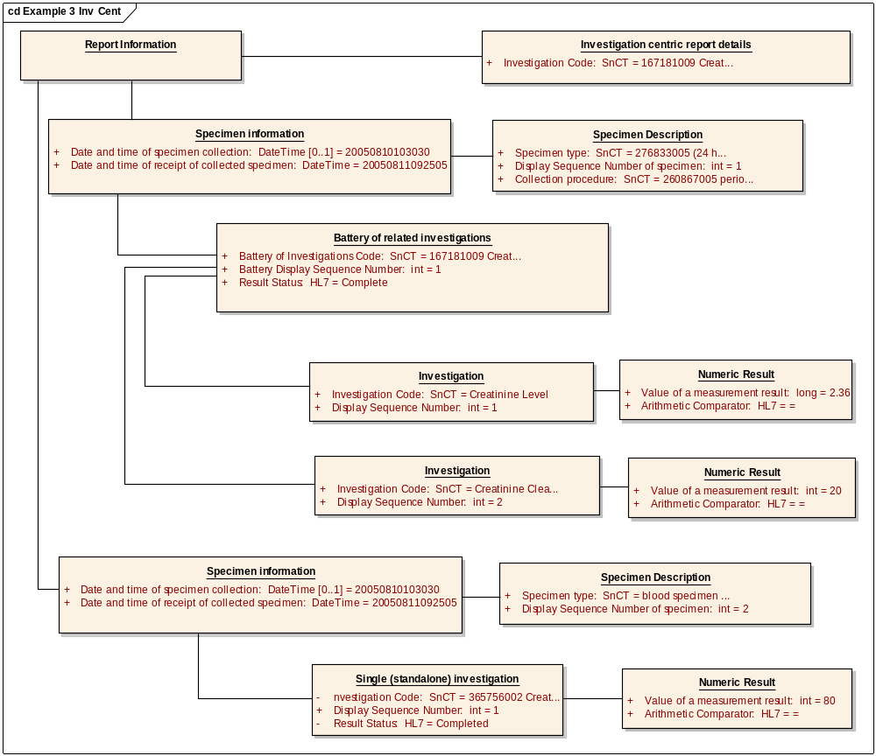

Report Information
Object:

Investigation centric report details
Object:

Investigation centric report details Attributes
Attribute | Type | Notes
Investigation Code | SnCT | Initial Value: 167181009 Creatinine Clearance Test

Specimen information
Object:

Specimen information Attributes
Attribute | Type | Notes
Date and time of specimen collection | Range:0 to 1:  DateTime | Initial Value: 20050810103030
Date and time of receipt of collected specimen | DateTime | Initial Value: 20050811092505

Specimen Description
Object:

Specimen Description Attributes
Attribute | Type | Notes
Specimen type | SnCT | Initial Value: 276833005 (24 hour urine sample)
Display Sequence Number of specimen | int | Initial Value: 1
Collection procedure | SnCT | Initial Value: 60867005 period of collection: Value: 24 hrs  404230009 specimen volume: Value 1000ml

Battery of related investigations
Object:

Battery of related investigations Attributes
Attribute | Type | Notes
Battery of Investigations Code | SnCT | Initial Value: 167181009 Creatinine Clearance Test
Battery Display Sequence Number | int | 1
Result Status | HL7 | Initial Value: Complete

Investigation
Object:

Investigation Attributes
Attribute | Type | Notes
Investigation Code | SnCT | Initial Value: Creatinine Level
Display Sequence Number | int | Initial Value: 1

Numeric Result
Object:

Numeric Result Attributes
Attribute | Type | Notes
Value of a measurement result | long | Not all attributes displayed for reasons of clarity  Initial Value: 2.36
Arithmetic Comparator | HL7 | Initial Value: =

Investigation
Object:

Investigation Attributes
Attribute | Type | Notes
Investigation Code | SnCT | Initial Value: Creatinine Clearance Test
Display Sequence Number | int | Initial Value: 2

Numeric Result
Object:

Numeric Result Attributes
Attribute | Type | Notes
Value of a measurement result | int | Not all attributes displayed for reasons of clarity  Initial Value: 20
Arithmetic Comparator | HL7 | Initial Value: =

Specimen information
Object:

Specimen information Attributes
Attribute | Type | Notes
Date and time of specimen collection | Range:0 to 1:  DateTime | Initial Value: 20050810103030
Date and time of receipt of collected specimen | DateTime | Initial Value: 20050811092505

Specimen Description
Object:

Specimen Description Attributes
Attribute | Type | Notes
Specimen type | SnCT | Initial Value: blood specimen (specimen) 119297000
Display Sequence Number of specimen | int | Initial Value: 2

Single (standalone) investigation
Object:

Single (standalone) investigation Attributes
Attribute | Type | Notes
Investigation Code | private :  SnCT | Initial Value: 365756002 Creatinine Level
Display Sequence Number | int | Initial Value: 1
Result Status | private :  HL7 | Initial Value: Completed

Numeric Result
Object:

Numeric Result Attributes
Attribute | Type | Notes
Value of a measurement result | int | Not all attributes displayed for reasons of clarity  Initial Value: 80
Arithmetic Comparator | HL7 | Initial Value: =

